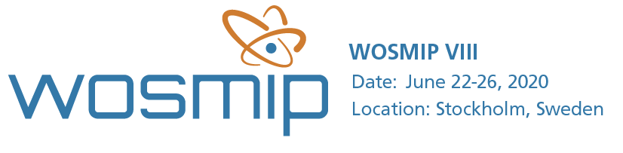

16 January 2020
Dear friends,
Registration is now open for the 8th Workshop on Signatures of Man-Made Isotope Production (WOSMIP VIII) being held in Stockholm, Sweden, from 22-26 June, 2020. To register, please visit our website at www.wosmip.org.
The workshop will be hosted by the Swedish Defence Research Agency (FOI) and supported by Pacific Northwest National Laboratory. It aims to support the Provisional Secretariat of the Preparatory Commission of the Comprehensive Nuclear-Test-Ban Treaty Organization and unite experts from radioisotope and nuclear explosion monitoring communities for a four-day friendly scientific meeting. WOSMIP provides a unique forum for technical discussions and collaborations to discuss the impact of radioisotopes released from civil and industrial sources on nuclear explosion monitoring in support of the Comprehensive Nuclear-Test-Ban Treaty.
Support from both communities is critical to maintaining the success of previous WOSMIPs, and new participation is strongly encouraged. The focus of WOSMIP VIII shall include radioisotopes released from nuclear power plants, research reactors, and medical and industrial isotope production. Agenda topics shall include but are not limited to:
- Anthropogenic sources of noble gas and particulate radioactivity
- Research to enhance detectability of nuclear explosion signals by the IMS against atmospheric background
- Current ⁹⁹Mo production overviews
- Stack Measurements and applications
- Events of interest

Participants are encouraged to register early. Passport holders may need a visa to visit Sweden. Please see our website to determine if a visa is required for your attendance and participation.
Additional information regarding the workshop venue, accommodation and logistics is also available through our website. The WOSMIP VII report is now available here.

We look forward to you joining us at WOSMIP VIII.

Best regards,
The WOSMIP Organization Committee

