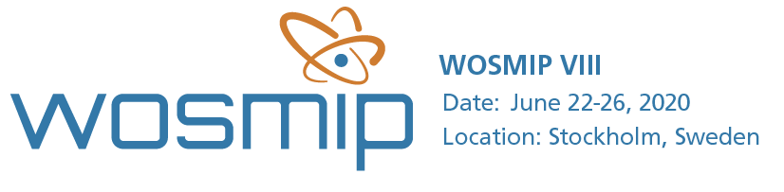

Dear All,
Be sure to register for the 8th Workshop on Signatures of Man-Made Isotope Production (WOSMIP-VIII) being held in Stockholm, Sweden, June 22-26, 2020!
Registration: Please visit our website to register.
Abstracts: We are now accepting both oral and poster session abstracts. If you are planning to submit an abstract be sure to do so by March 6th!
The workshop will be hosted by the Swedish Defence Research Agency (FOI) and supported by Pacific Northwest National Laboratory. It aims to support the Provisional Secretariat of the Preparatory Commission for the Comprehensive Nuclear-Test-Ban Treaty Organization and unite experts from radioisotope and nuclear explosion monitoring communities for a four-day friendly scientific meeting.
WOSMIP provides a unique forum for technical discussions and collaborations to discuss the impact of radioisotopes released from civil and industrial sources on nuclear explosion monitoring in support of the Comprehensive Nuclear-Test-Ban Treaty.
Support from both communities is critical to maintaining the success of previous WOSMIPs, and new participation is strongly encouraged. The focus of WOSMIP VIII will include radioisotopes released from nuclear power plants, research reactors, and medical and industrial isotope production.
Agenda topics will include but are not limited to:
- Anthropogenic sources of noble gas and particulate radioactivity
This session will include the sources of background radioactivity in the environment. Of particular interest is the source terms from research reactors, nuclear power plants, and potential future sources such as molten salt reactors or use of xenon in industrial processes.

- Research to enhance detectability of nuclear explosion signals by the IMS against atmospheric background
This session will include research into the development of new abatement technologies to reduce releases from facilities, the use of tools such as atmospheric transport modeling to discriminate source terms and new advances in detection technology.

- Current ⁹⁹Mo production overviews
This session will include updates on the status of world-wide fission based ⁹⁹Mo production, both current and future production.

- Stack Measurements and applications
This session will include the development and use of source term stack release measurements; stack measurement technology; processing of stack measurement data; and use of stack measurement data to understand global xenon backgrounds

- Events of interest
This session will include specific examples of background events and lessons learned from their detection.

Important Note Regarding Visas
Participants are encouraged to register early. Passport holders may need a visa to visit Sweden. Please see our website to determine if a visa is required for your attendance and participation.
Additional information regarding the workshop venue, accommodations and logistics is also available through our website. The WOSMIP VII report is now available here.

We look forward to you joining us at WOSMIP VIII,
The WOSMIP Organization Committee

